Application for an event to be allocated
Continuing Professional Development (CPD) NRoSO points
COMPLETION OF BOTH PAGES OF THIS FORM IS ESSENTIAL FOR YOUR EVENT TO BE CONSIDERED FOR CPD
Please submit the form 2 weeks prior to the event for points to be allocated. Any applications received after the event date will not be eligible for pointing
NRoSO POINTS WILL ONLY BE AWARDED FOR COURSES/EVENTS CONTAINING PESTICIDERELATED CONTENT
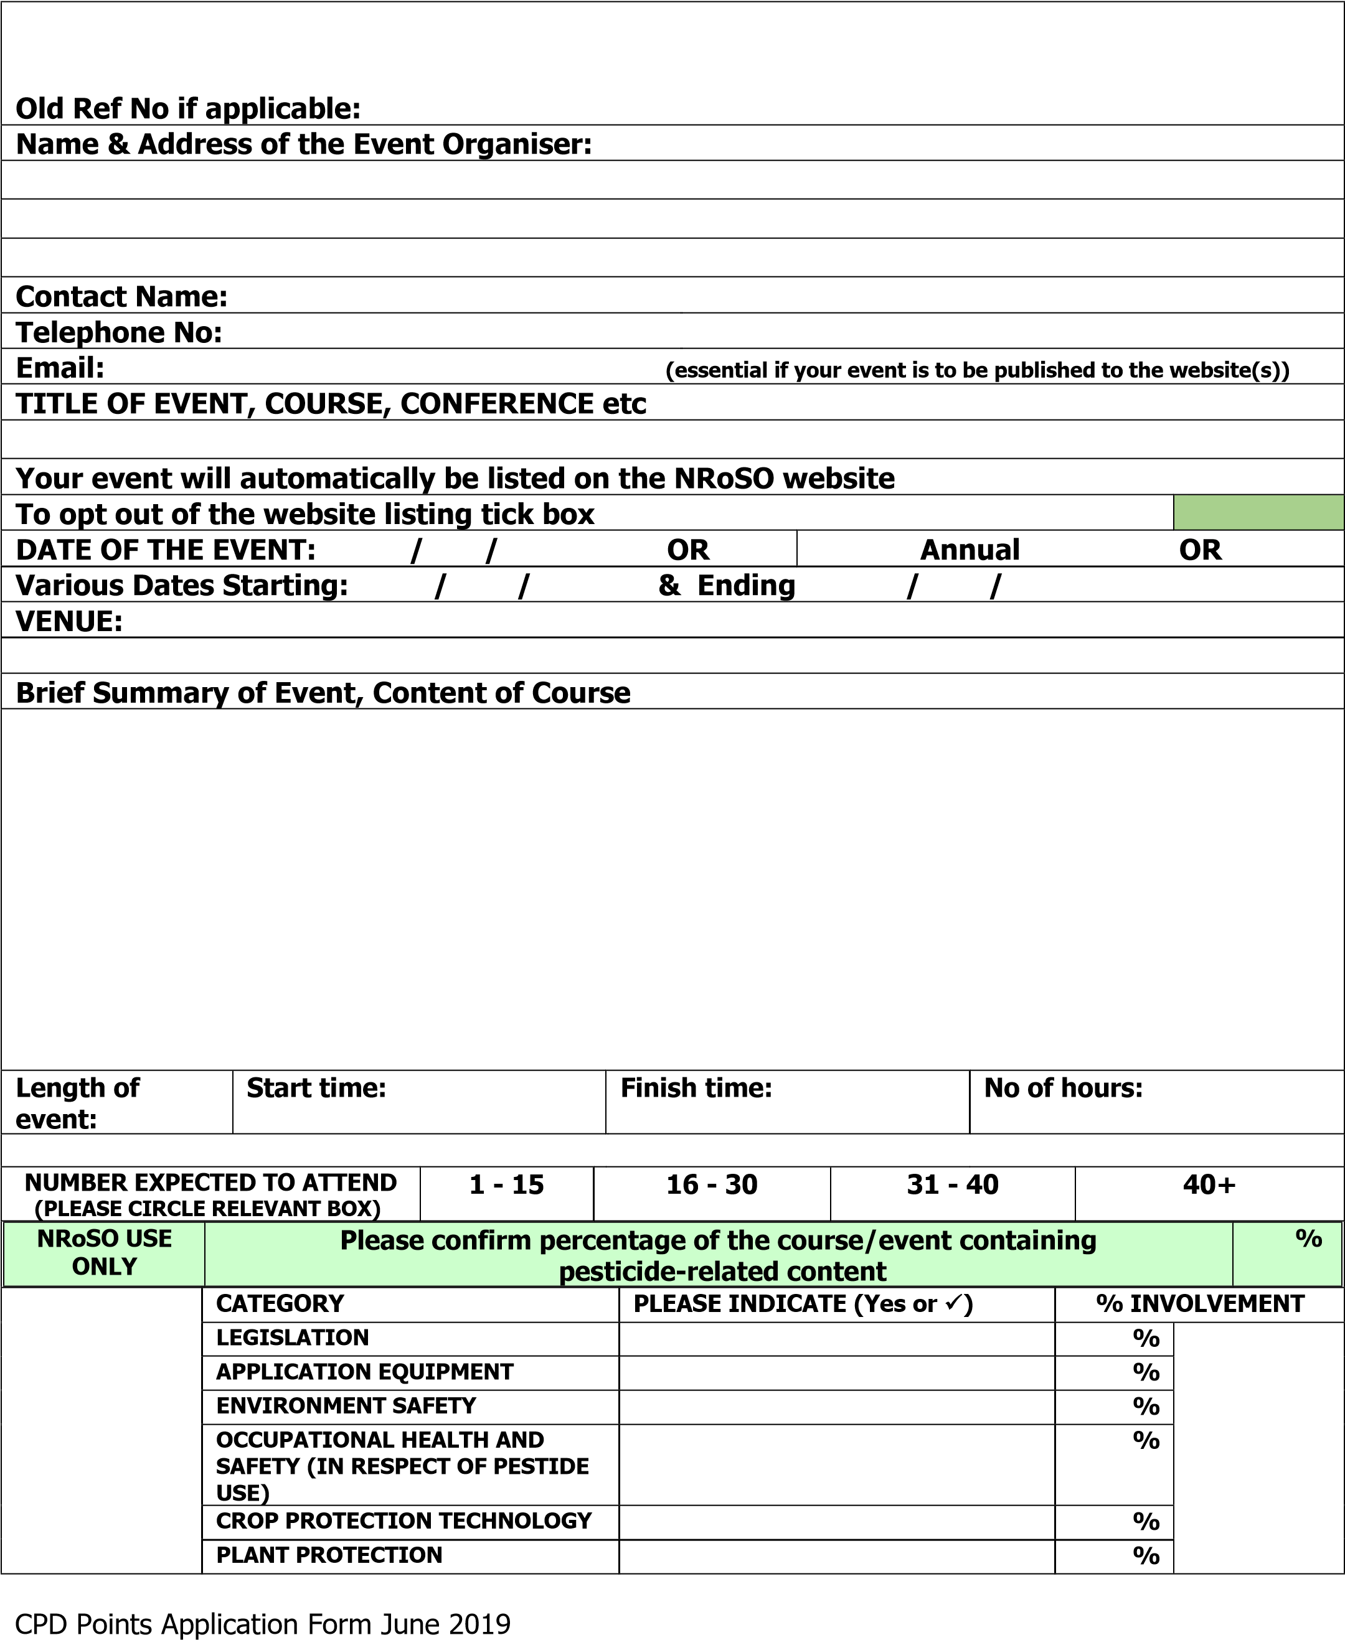
 | INTEGRATED CROP MANAGEMENT |  |  |  |  |  |  |  | %
Activity |  |  |  |  |  | Please Tick Activity Type |  | Max points allocated per  membership year |  |  | Max permitted points for this type of event  over the 3 year  membership term
Participative Training Event/Pesticide Assessment |  |  |  |  |  |  |  | 12 |  |  | 30
Meeting with an Agronomist (2 points per meeting) |  |  |  |  |  |  |  | 4 |  |  | 12
Technical Updates and Seminars |  |  |  |  |  |  |  | 8 |  |  | 24
Open Technical Conferences |  |  |  |  |  |  |  | 6 |  |  | 18
Open Technical Events/Specialist shows |  |  |  |  |  |  |  | 4 |  |  | 12
Membership/subscription for technical notes/journals (trade magazines no longer accepted from 01/01/2010) |  |  |  |  |  |  |  | 2 |  |  | 6
Online distance learning (2 points per online module) |  |  |  |  |  |  |  | 4 |  |  | 12
Attending NSTS sprayer/fogger test |  |  |  |  |  |  |  | 3 |  |  | 9
NRoSO annual training event |  |  |  |  |  |  |  | 10 |  |  | 30
HOW WILL THIS EVENT BE EVALUATED? PLEASE CIRCLE RELEVANT RESPONSE(S)
Examination |  |  | Discussion |  |  |  | Questionnaire |  |  | None
Other (please give details):
FOR OFFICE USE ONLY |  | Event Reference No |  | Points breakdown |  |  |  |  |  |  |  | CPD points total
NRoSO |  |  |  | N/A
Approved by: Date:
NB – Signed attendance lists will be required for each event.
Please return all completed forms by email to:
nroso@basis-reg.co.uk

NRoSO, BASIS Registration Limited, St Monica’s House, 29 Windmill Lane, Ashbourne, Derbyshire, DE6 1EY Tel: 01335 210849

